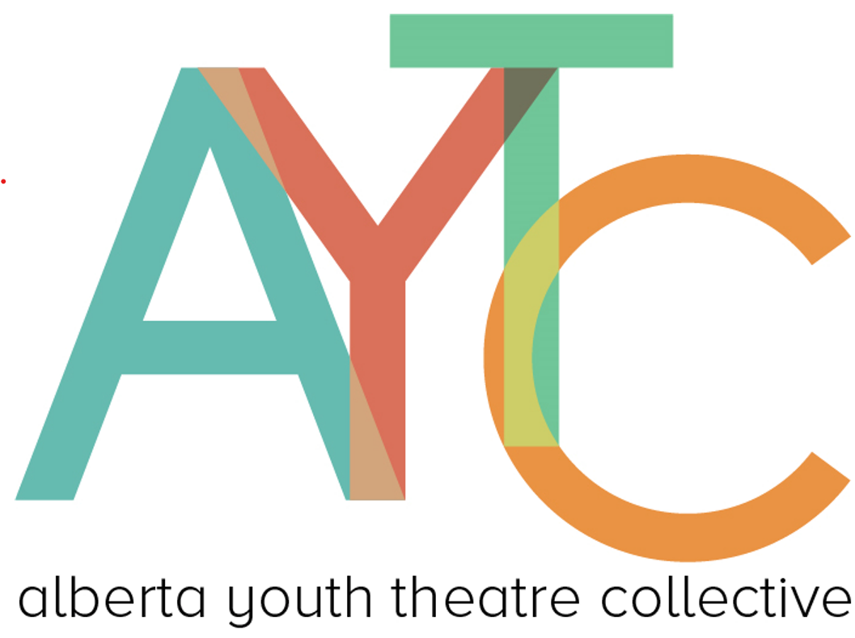

Alberta Youth Theatre Collective (AYTC)

Code of Conduct and Expectations & Procedures Updates
Dear Schools, Teachers, Reviewers and Parents,
We are excited to welcome you to the 2025–2026 Alberta Youth Theatre Collective season. To support every student reviewer and foster a safe, respectful community, we have released two updated documents:
- Expectations & Procedures
- Code of Conduct
These documents outline our updated accountability framework, clear participation standards, and zero-tolerance abuse policy. As part of the Alberta Youth Theatre Collective (AYTC), it is essential that each school fulfills its commitment to the program in the form of show attendance, review and star submission, professional conduct, and fostering a safe environment for all.
Key Updates:
Training Day:
- All reviewers, alternates and Lead Teachers MUST attend Training Day. Completion of training is required for participation of all members of an AYTC team.
  - If you cannot make Training Day (November 29th), there will be a ONE DAY make up of all sessions.
  - If any member of a school’s AYTC team does not attend training day or the make-up day, that member will no longer be eligible to participate in the present season.
Show Assignment, Sign-Up and Submissions:
- Show Assignments for all shows will be due on Training Day this year. There is no change to the required 2 members per show.
  - All show dates will be released before Training Day (approx. 2 weeks before)
  - We recognize that early sign-up may lead to changes throughout the season. Please notify the Executive Director of all changes as soon as possible. As long as you fulfill your 2 reviewer requirement, there are zero consequences for substitutions to your submission on Training Day.
- Review and Star-Allocation Deadlines are standardized this year and are as follows:
  - If you attend a show on Wednesday or Thursday, review and star-allocations are due on Sunday at 12pm (noon).
  - If you attend a show on Friday or Saturday, review and star-allocations are due on Tuesday at 5pm
Absence Protocol:
Review and acknowledgement of the full document is required. Below are some key points.
- First unexcused absence or missed submission will elicit a formal written warning and follow-up support conversation.
  - Continued lapses from the same team member or team as a whole may lead to a member stepping down and/or team-level award ineligibility
- A review team's award eligibility will not affect a school’s production award eligibility unless the review team withdraws from participation fully.
  - As always, productions of any AYTC participating school will be offered a performance block at the gala, regardless of award eligibility.
Code of Conduct:
Review and acknowledgement of the full document is required. Below are some key points.
- Professional standards for communication, inclusion and mentorship
- Zero tolerance for any form of abuse, with detailed reporting steps, documentations and confidentiality safeguards.
- This document protects all participants of AYTC including (but not limited to): reviewers, teachers, cast and crew, AYTC Board, audience members and contracted mentors.
Why This Matters
AYTC is committed to creating an equitable and cooperative environment for all schools involved. All documents and policies help ensure that all members remain engaged and responsible, reinforcing the spirit of collaboration. By maintaining full and safe participation, we honor the efforts of everyone involved whether on stage, in the audience or behind the scenes.
We appreciate your understanding and cooperation. Please feel free to contact us with any questions or concerns about new expectations, policies or procedures.
Thank you for your dedication to the Alberta Youth Theatre Collective.
Warm regards,
The Alberta Youth Theatre Collective Board of Directors

