Documentation Checklist

This document acts as a suggested tracking form. However, you may already have a tracking system in place for your production crew. Please feel free to use what works best for you and let this resource guide your understanding of the level of documentation AYTC is looking for.
If you have any questions at all, please do not hesitate to reach out to a board member for clarification or support.

HAPPY DOCUMENTING!

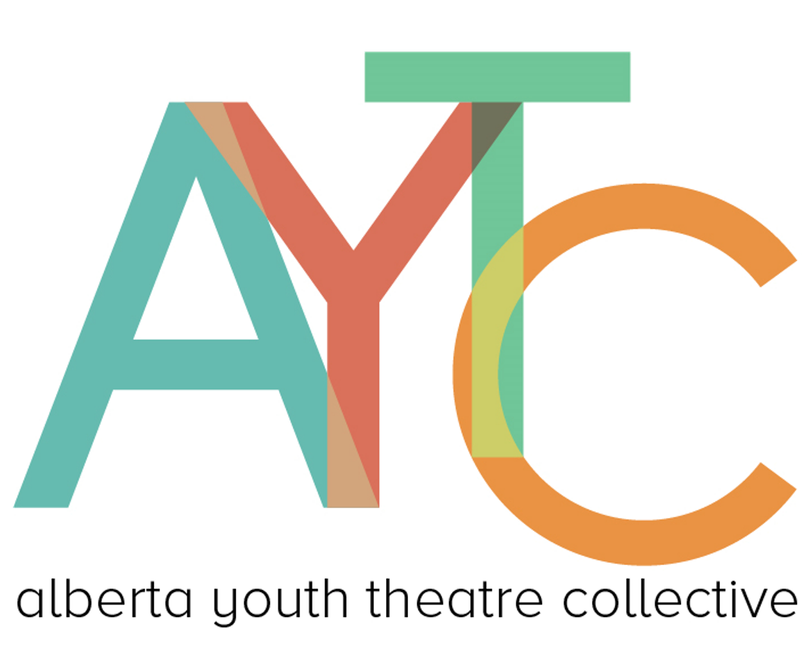

Set & Prop Design
Documentation Tasks | Student Responsibility  70% | Adult Responsibility  30% | Forms of Evidence (photos, sketches, videos, written reflection, etc)
Initial Sketches, Mood boards or Models
Research Images
- Time period (if a time period show)
- Architecture
- Landscapes
Construction Progress
(safety taken into account)
- Build instructions or step-by-step diagrams
- Material lists (wood, fabric, paint types, hardware)
- Measurements and cut lists

Prop List
- Prop name
- Scene(s) used
- Who uses it
Set List
(sourced material notes)
If Your Team Does Something That is Not Listed (please fill in here)

Lighting
Documentation Tasks | Student Responsibility  70% | Adult Responsibility  30% | Forms of Evidence (photos, sketches, videos, written reflection, etc)
Lighting Plot & Cue Sheet

Setting Up the Lighting Board
Purchasing of New Lights
(sourcing information)
Hanging and Focussing of Lights

Running/Calling a Show
(script mark-up)

If Your Team Does Something That is Not Listed (please fill in here)

Sound
Documentation Tasks | Student Responsibility  70% | Adult Responsibility  30% | Forms of Evidence (photos, sketches, videos, written reflection, etc)
Sound Cues
- Mics
- Sound effects
- Musical Backing Tracks

Setting Up the Sound Board, and other equipment.

Running/Calling a Show
(script mark-up)

If Your Team Does Something That is Not Listed (please fill in here)

Stage Management
Documentation Tasks | Student Responsibility  70% | Adult Responsibility  30% | Forms of Evidence (photos, sketches, videos, written reflection, etc)
Prompt Book
- Script with cues: lights, sound, set moves, special effects
- Cue sheets (separate documents for LX, SFX, projections)
- Blocking notes
- Standby, warning, and GO cues marked clearly
- Scene-by-scene breakdown of technical needs
- Spike tape/map documentation
Rehearsal Process
- Daily Rehearsal Reports
- Blocking Notes
Schedule
- Rehearsal Schedules
Spike mark documentation
(floor tape colours and locations)
Leadership & Team Organization
Roles & Responsibilities
- Assistant stage manager tasks
- Crew chief assignments
- Props table manager
- Head of transitions
Show Run
If Your Team Does Something That is Not Listed (please fill in here)

Costuming
Documentation Tasks | Student Responsibility  70% | Adult Responsibility  30% | Forms of Evidence (photos, sketches, videos, written reflection, etc)
Research & Design
- Research the time period, culture, and style relevant to the production

Costume Sketches
- Develop mood boards or style guides for each character or group

Performer Fittings and Alteration Logs
- Sew, alter, or embellish costumes to fit actors and match the design vision
- Add trims, patches, buttons, or decorations
- Repair worn or damaged items
- Create costume elements from scratch (hats, props, masks)

Costume Plot
- Create a detailed list (costume plot) showing what each actor wears in each scene
- Track accessories, wigs, makeup needs, and footwear
- Quick changes or multiple costume sets if needed

Costume Organization
Purchasing of Costumes
(sourcing information)
If Your Team Does Something That is Not Listed (please fill in here)

Hair & Make-Up
Documentation Tasks | Student Responsibility  70% | Adult Responsibility  30% | Forms of Evidence (photos, sketches, videos, written reflection, etc)
Face Charts (sketches)
References of Looks
Product List & Application Notes
Test Photos/Videos
If Your Team Does Something That is Not Listed (please fill in here)

Marketing
Documentation Tasks | Student Responsibility  70% | Adult Responsibility  30% | Forms of Evidence (photos, sketches, videos, written reflection, etc)
Program Design (drafts)
Poster Design or Show Logo
Social Media Plan (timeline of posts)
Storyboarding and Film Techniques
Collection of Marketing Materials
- Backstage Photos
- Headshots
- Rehearsal photos
- Cast and Crew interviews
If Your Team Does Something That is Not Listed (please fill in here)

Choreography
Documentation Tasks | Student Responsibility 70% | Adult Responsibility 30% | Forms of Evidence (photos, sketches, videos, written reflection, etc)
Dance Notation/Choreo Planning
Progress/Rehearsal Videos
If Your Team Does Something That is Not Listed (please fill in here)

Featured Artistry
Documentation Tasks | Student Responsibility  70% | Adult Responsibility  30% | Forms of Evidence (photos, sketches, videos, written reflection, etc)
Featured Artistry documentation suggestions:
- A description of the artistic contribution and why it was featured
- Photos or videos showing the showcased skill
- Notes about the student’s creative process
- Rehearsal logs or reflection from the featured artist(s)
- Explanation of how the artistry elevated the production

Orchestra
Documentation Tasks | Student Responsibility 70% | Adult Responsibility 30% | Forms of Evidence (photos, sketches, videos, written reflection, etc)
Rehearsal Schedule
- Dates, times, and locations for orchestra/band rehearsals
Music Scores & Parts
- List of all music pieces and arrangements
- Copies of individual parts for each musician (digital and/or paper)
- Marked-up scores showing conductor cues, dynamics, and tempo changes
- Any custom arrangements or transcriptions
Set List & Cues
- Detailed list of songs/music cues in show order
- Cue sheet for lighting and sound teams referencing musical moments
If Your Team Does Something That is Not Listed (please fill in here)

